Saad Dahlab University of Blida Academic year2025/2026

Computer Science Department -1st Year LMD- Subject: Fundamental Electronic

Semester : 2

Exercise Series 1

Exercise 1 (course)

Consider the circuit in the following figure. We aim to determine the current intensities in the three branches. Given that: R1 = 2 Ω; R2 = 5 Ω; R3 = 10 Ω; E1 = 20 V; E2 = 70 V.
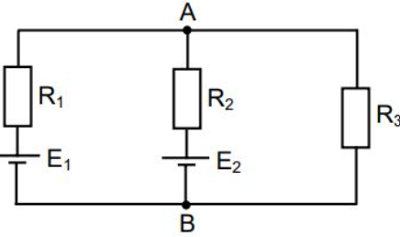

Exercise 2
Consider the following circuit:

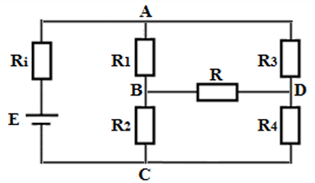

- Indicate the number of nodes, the number of branches, and the number of loops.
- In the following part of the exercise, the BD branch is removed and eliminated from the circuit. We are given $R_{1}=R_{2}=R_{3}=R_{4}=1 Ω$, $R_{i}=4 Ω$, and $E=10\text{ V}$. Calculate the currents passing through each resistor.

Exercise 3 (course)

Using Voltage Divider Theorem
- Determine $U_{BM}$as a function of $U_{AM}$.
- Determine $U_{AM}$, then $U_{BM}$, as a function of $E$

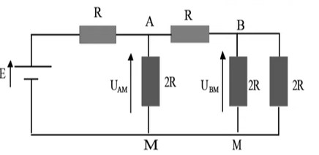

Exercise 4

Consider the following circuit. We are given:

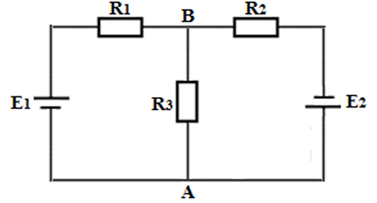
Calculate the current intensity in the AB branch by applying:
- Kirchhoff's Laws
- The Superposition Theorem
Exercise 5
Consider the following circuit.
Using the superposition method, find the currents $I_{1},I_{2},I_{3},$and $I_{4}$.
Derive the potentials $V_{A},V_{B},V_{C},V_{D},$and $V_{H}$, taking point D as the origin of the potentials.
Given: $R_{1}=100 Ω,R_{2}=50 Ω,R_{3}=100 Ω,R_{4}=50 Ω,R_{5}=50 Ω$.
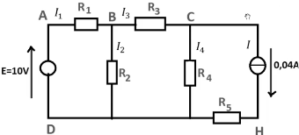
Exercise 6 (course)
We consider the electrical circuit given by the following figure:
- We are given: $E_{1}=10 V$; $E_{2}=5 V$; $R_{1}=R_{3}=R_{4}=100 Ω$; $R_{2}=50 Ω$.
- Calculate the current $I$by applying Thévenin's theorem
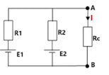
Exercise 7
We consider the given electrical circuit below. The electromotive forces of the generators are given as $E_{1}=10 V$and $E_{2}=8 V$, the resistances $R_{1}=R_{2}=R_{3}=200 Ω$, and the load resistance $R=100 Ω$.

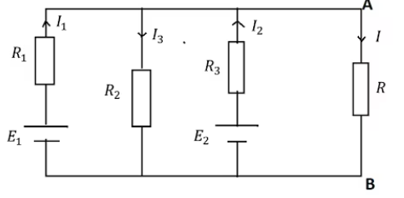

- Using Norton's theorem, calculate the current that passes through the load $R$and deduce the voltage $U_{AB}$.
- Using Thévenin's theorem, calculate the voltage $U_{AB}$and deduce the current $I$.

